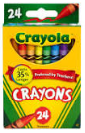
Lenz Elementary School 23-24

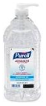
1st Grade Supply List:
- 18-24 Elmer glue sticks
- 12 sharpened Ticonderoga Pencils
- Crayola Colored Pencils 12
- Crayola Crayons 24
- Crayola Markers 10
- Astrobrights color paper (not cardstock)
- Large Hand Sanitizer
- Clorox Wipes
- 1 box of Ziplocks (boys- gallon freezer bag, girls- quart freezer bags)
- $30 classroom fee for science, field trips, art, and other activities/treats (cash or check - payable to Lenz Elementary)

